**Design & Technology**

**

**Paper and board finishing**

**Materials required for questions**

* Pencil
* Rubber
* Calculator

**Instructions**

* Use black ink or ball-point pen
* Try answer all questions
* Use the space provided to answer questions
* Calculators can be used if necessary
* For the multiple choice questions, circle your answer

**Advice**

* Marks for each question are in brackets
* Read each question fully
* Try to answer every question
* Don’t spend too much time on one question

**Good luck!**

**Q1.** What is the primary purpose of laminating paper or board?

**A** To add a metallic finish

**B** To increase thickness and durability

**C** To create raised patterns

**Q2.** Embossing is a finishing technique that:

**A** Presses a design into the surface to create a raised effect

**B** Uses heat to transfer metallic foil onto the material

**C** Applies a clear protective layer over the entire surface

**Q3.** Which finishing technique is the opposite of embossing?

**A** Foil blocking

**B** Debossing

**C** Spot varnishing

**Q4.** What is an advantage of UV varnishing compared to traditional varnishing?

**A** It is only applied to specific areas

**B** It dries instantly under UV light

**C** It creates a metallic finish

**Q5.** Explain why each of the following finishing techniques have been used **(3 x 2 marks)**

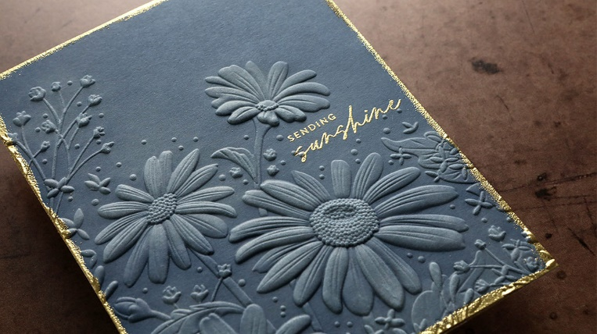

Embossing

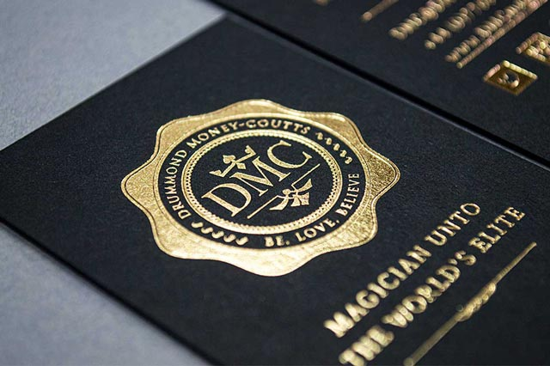

Foil blocking

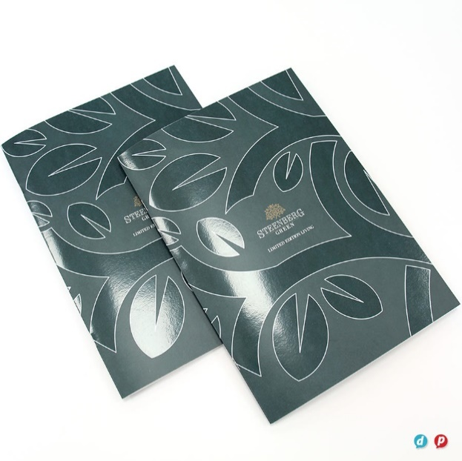

Spot varnishing

**Q6.** A logo is to be applied to a gift box using either foil blocking or embossing.

Evaluate the suitability of these two processes in terms of:

* aesthetics
* cost
* environmental issues

**(6 marks)**

**Answers**

**Q1**. B

**Q2**. A

**Q3**. B

**Q4**. B

**Q5.**

Embossing

* Produces a raised design that stands out from the white card. (1 mark)
* Produces a raised design that adds depth to the card and allows for the design to be the same colour as the card without additional printing. (2 marks)

Foil Blocking

* Creates a metallic logo or text on the badge cover. (1 mark)
* Provides aesthetic enhancement to the logo and text by providing contrast with the blue-black base colour of the passport due to its metallic properties. (2 marks)

Spot varnishing

* Produces areas of high gloss over the images and text. (1 mark)
* Adds a high gloss coating to the images and text, improving the aesthetic and accentuating the individual details. (2 marks)

**Q6.**

Aesthetics:

* Foil blocking adds high quality appearance and contrast to the package.
* Embossing can have ink applied or be left as a ‘blind embossing’.
* Embossing gives a subtle aesthetic only visible in certain lighting due to single colour package.
* Embossing gives a tactile effect to the packaging.
* Foil blocking is available in metallic and holographic finishes adding to the quality of the product.

Cost:

* Embossing uses a single material and manufacturing process as it can be done during die cutting, reducing costs.
* Foil blocking adds cost due to adding a second material and adhesive, but this can be offset by the increased retail cost of the product.

Environmental issues:

* Embossed packages can be easily recycled due to the single material use.
* Embossing can be performed on FSC certified papers, and cards.